______________________________________________________________________

United Nations   
Department of Economic and Social Affairs

Statistics Division  
 Economic Statistics Branch  
______________________________________________________________________

08 Nov 2018

Classifications: Broad Economic Categories

Progress on Establishing Correlations

Note by UNSD

**Background**

1. The fifth revision of BEC was endorsed by UN Statistical Commission in 2016. This revision (BEC 5) is defined in terms of HS 2012 sub-headings and CPC 2.1 classes for goods and services, respectively. It differs than BEC 4 due to addition of services, redesigned top level of broad economies and new variables (specification dimension). See illustration below (Figure 1).

Figure 1. Illustration of BEC 5 structure.

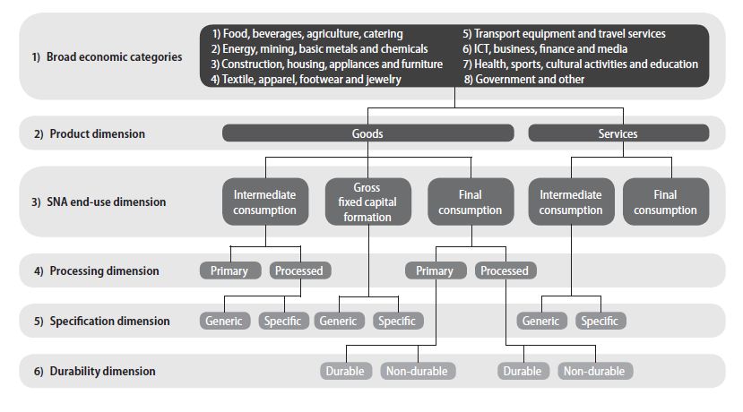

1. With its adoption, focus has now shifted to finalizing the correspondence tables between BEC 5 and HS/ CPC/ EBOPS /ISIC. Those correspondence tables will be posted on the website of UNSD as soon as possible; starting with correlations between BEC 5 and HS 2017.
2. The primary objective of establishing correlations (or relationships) between HS/CPC/EBOPS and BEC/ISIC is to facilitate data conversion from primary classifications which are used to collect and compile basic data, thus reducing burden (rather than collect data in BEC). UNSD maintains correlations among trade related classifications[1].

**Principles**

1. The principle of predominant **use of a goods** (or services) can be used when establishing correlations between BEC and other classifications. See Box 1 below for an example.

Box 1. An example of considerations to assign a specific product to a BEC 5 category

|  |
| --- |
| A tractor is predominantly a capital investment in the agriculture sector. It is not predominantly used as a personal vehicle. Therefore, the tractor would be allocated as (1) agriculture, (2) goods, (3) capital goods, (4) --, and (5) generic. Parts of a tractor would however be allocated as (1) transport, (2) goods, (3) intermediate goods, (4) processed, (5) specific, and (6) durable. Some parts could probably be generic.  Dual use goods such as passenger motor cars are used extensively both for industry and for household consumption. Therefore, they could be allocated as (1) transport, (2) goods, (3) final or capital goods, (4) processed, (5) generic or specific, and (6) durable or non-durable. The proportion of dual use depends on national circumstances. |

* 1. 1st LEVEL (BEC dimension): Map HS sub-headings and CPC classes to the first top level of broad economic categories. Because a basis for the construction of those main economic classes is ISIC, then we need to decide whether to consider a goods or services as input or output to specific industries. For example, a computer is an output of ICT industry; but it can be used as input to any industries (or depends on what kind of computers). This implies whether we need to establish different correlations between imports and exports.
  2. 2nd LEVEL (Product dimension): There is no need for much work here. Goods and services are quite distinct and there are existing guidelines on how to classify them.
  3. 3rd LEVEL (End-use dimension): Even though, this may be challenging, but for goods, we can reuse (and review) existing correlations between BEC 4 and HS 2012[2]. On the contrary, for services, we may need to reach out to experts. In addition, some goods, such as personal vehicle, can have dual use, namely as capital good and as final consumption good (or gasoline – as intermediate and final consumption). They need to be flagged and given a footnote, which indicates that the proportion of dual use should be determined at national level.
  4. 4th LEVEL (Processing dimension): Similar with 3rd level, for goods, we can refer to existing correlations between BEC 4 and HS 2012. Note: this level is not applicable for services.
  5. 5th LEVEL (Specification dimension): This is new dimension, therefore requires more research to establish correlations. The idea is to identify position (downstream/upstream) of goods/services within value-added chain (see illustration below, Figure 1). We would rely on industry experts and existing literatures. This is to be done case-by-case basis (and the problem is that HS categories may not be detailed enough).

Figure 1. BEC Rev.5, value-added chain

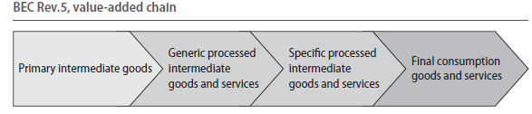

1. 6th LEVEL (Durability dimension): Similar with 3rd and 4th levels, we can reuse existing correlations between BEC 4 and HS 2012 for goods. This dimension is not applicable for services.
2. Apparently, the main analytical use of the classification is to understand the predominant use of a goods (or services), entailing that the main consideration is the use of (or services), or as inputs to the economic activities. That is, correlations based on the principle of output can be considered alternative or secondary.

**Methodology or Mechanics of Establishing Correlations**

1. Several tools or draft documents are already available. See Box 2 below for available draft working files.

**Box 2. Available working data files**

|  |
| --- |
| * Draft correspondences between BEC 5 and HS 2012 / EBOPS 2010 developed during the drafting of BEC 5 manual * Existing correspondences between BEC 4 and HS at 4-digit and 6-digit levels to ISIC v.3, ISIC v.4.0, CPC v.1.1, GTAP and BEC End-Use with possible breakdown among intermediate, consumption and capital (no HS 2017) developed by OECD and USITC * Existing correspondences between BEC 4 and HS 2017 and earlier HS editions developed by UNSD |

**BEC 4 to other classifications (including HS 2017)**

1. We started by comparing existing BEC 4 correlations with other classifications developed separately by OECD/USITC and UNSD. The discrepancies were identified and analysed. In July 2018, we shared the file containing discrepancy of 80 HS codes (each sub-heading HS codes to be classified to primary or processed goods) with WCO requesting their feedback.
2. Applying UNSD correlation tables between BEC 4 and HS 2017 and HS 2012 and HS 2017, we complemented OECD/USITC table with HS 2017 codes. The output file is called OECD/USITC/UNSD table. Even though, most of HS 2017 codes correlations could be derived from HS 2012 codes with following rules:
   1. Keep pre-defined correlations of 1-to-1, n-to-1, and n-to-n (with retained codes) relationships between HS 2017 and HS 2012
   2. The rest would be done manually based on description of similar HS codes

And the other HS 2017codes are to be correlated manually (by comparing with existing correlations with similar descriptions). All records added by UNSD are flagged accordingly.

**BEC 5 to other classifications.**

1. Undertake manual verification on draft correspondences between BEC 5 and HS 2012 / CPC. For verification, we followed the following procedures (HS 2012):
   1. Review existing draft and compare SNA end-use dimension with BEC 4. Adjustment was made if necessary. To the extent possible, possible dual end-use was identified and then necessary correspondence was added.
   2. Review and adjust the processing and durability dimension (Primary vs. Processed) taking into account the definition from original formulation of BEC[3]. See also description on BEC 5 paras 3.10-3.11 and 3.17-3.18
   3. Review and adjust the specification dimension following guidelines from BEC 5 paras 3.12-3.16. Further, we also crossed check the result against *existing* some GVC definition lists[4] consisting of automobile, textile, apparel, footwear and electronic.
   4. Finally, to the extent possible, corresponding BEC 5 codes were designated at the most detailed level. If not, then the next higher-level code would be selected (i.e., if specification dimension cannot be determined, then it would be marked “GEN/SPEC”).

Table 1. Summary correspondence between HS 2012 and BEC 5

|  |  |  |  |  |
| --- | --- | --- | --- | --- |
| BEC 5 Dimension | | | |  |
| End Use | **Processing** | **Specification** | **Durability** | **No of HS codes** |
| CAP |  | GEN/SPEC | | 96 |
| CAP |  | GENERIC |  | 344 |
| CAP |  | SPECIFIC |  | 191 |
| CAP/CONS | | GENERIC |  | 7 |
| CAP/CONS | | SPECIFIC |  | 9 |
| CAP/INT |  | GENERIC |  | 28 |
| CAP/INT |  | SPECIFIC |  | 6 |
| CONS | PRIMARY |  | DURABLE | 1 |
| CONS | PRIMARY |  | NON-DURABLE | 557 |
| CONS | PROCESSED | | DURABLE | 532 |
| CONS | PROCESSED | | NON-DURABLE | 109 |
| CONS/CAP | PROCESSED | | DURABLE | 66 |
| CONS/INT | PRIMARY |  | NON-DURABLE | 25 |
| CONS/INT | PROCESSED | | DURABLE | 80 |
| CONS/INT | PROCESSED | | NON-DURABLE | 14 |
| INT | PRIMARY |  |  | 337 |
| INT | PROCESSED | GEN/SPEC | | 27 |
| INT | PROCESSED | GENERIC |  | 1087 |
| INT | PROCESSED | SPECIFIC |  | 1572 |
| INT/CAP | PROCESSED | SPECIFIC |  | 10 |
| INT/CONS | PRIMARY |  |  | 4 |
| INT/CONS | PROCESSED | GEN/SPEC | | 1 |
| INT/CONS | PROCESSED | GENERIC |  | 34 |
| INT/CONS | PROCESSED | SPECIFIC |  | 66 |

1. As for CPC/EBOPS, the verification task focused on ensuring that the right BEC description matches description of CPC/EBOPS. The processing and durability dimensions are not applicable on services, therefore, there are only three codes relevant to services: 1) Services – Intermediate Consumption – Generic; 2) Services – Intermediate Consumption – Specific; and 3) Services – Final Consumption. Unfortunately, CPC codes are not detailed enough to identify specification dimension, therefore, we can only make correspondence up to SNA end-use dimension (3rd level).

Table 2. Summary correspondence between CPC 2.1 and BEC 5

|  |  |
| --- | --- |
| End Use | No of CPC codes |
| CONS | 122 |
| INT | 167 |

1. Finally, by applying existing correspondence table between HS 2012 and 2017[5], we derived correlation between HS 2017 and BEC 5.

**Trade Data in BEC 5**

1. One way to clarify the correspondence is to apply it with trade data. In this regard, imports data of USA, UK, China, Germany and France from 2012 to 2016 were utilized to create comparison of end-use category between BEC 4[6] and BEC 5. There are no differences in intermediate goods; slight differences in capital goods; and relatively large differences in consumption goods. This may be due to limitation of conversion from HS to BEC 4 which allocates some trade to NES (see that the value of NES in BEC 4 is -much more- than BEC 5).

Table 3. Imports of USA, UK, China, Germany and France in BEC 4 and 5, 2012-2016

|  |  |  |  |  |  |
| --- | --- | --- | --- | --- | --- |
| **BEC Version** | **End-use** | **processing** | **specification** | **durability** | **2012-2016 (avg)** |
| 5 | CAP |  | GEN/SPEC |  | 194,867,025,217 |
| 5 | CAP |  | GENERIC |  | 199,909,091,767 |
| 5 | CAP |  | SPECIFIC |  | 552,954,593,598 |
| CAP BEC 5 |  |  |  |  | 947,730,710,582 |
| CAP BEC 4 |  |  |  |  | 1,027,700,027,453 |
|  |  |  |  |  | -8% |
| 5 | CONS | PRIMARY |  | DURABLE | 54,061,446 |
| 5 | CONS | PRIMARY |  | NON-DURABLE | 568,485,535,686 |
| 5 | CONS | PROCESSED |  | DURABLE | 1,086,917,528,258 |
| 5 | CONS | PROCESSED |  | NON-DURABLE | 80,330,176,393 |
| CONS BEC 5 |  |  |  |  | 1,735,787,301,784 |
| CONS BEC 4 |  |  |  |  | 1,330,591,157,664 |
|  |  |  |  |  | 29% |
| 5 | INT | PRIMARY |  |  | 836,909,600,000 |
| 5 | INT | PROCESSED | GEN/SPEC |  | 130,101,800,000 |
| 5 | INT | PROCESSED | GENERIC |  | 880,078,400,000 |
| 5 | INT | PROCESSED | SPECIFIC |  | 1,812,792,000,000 |
| INT BEC 5 |  |  |  |  | 3,659,881,800,000 |
| INT BEC 4 |  |  |  |  | 3,646,880,000,000 |
|  |  |  |  |  | 2% |
| 5 | NES |  |  |  | 211,714,600,000 |
| 4 | NES |  |  |  | 542,732,168,572 |
|  | TOTAL |  |  |  | 6,547,903,353,689 |
| Source: UN Comtrade | | |  |  |  |

1. Looking at broad economic categories (1st level) broken down by end-use, processing, specification and durability dimensions, it shows that high values of specialized intermediate goods are concentrated in BEC broad economic categories 5 and 6 which implies GVCs automobile and electronics, respectively. The largest value in broad economic category 2 is primary fuels which is basically a crude oil. And in processed final consumption, the broad economic categories 4 and 5 are quite significant.

Table 4. Imports of USA, UK, China, Germany and France in BEC 5 – Broad Economic Categories, 2012-2016

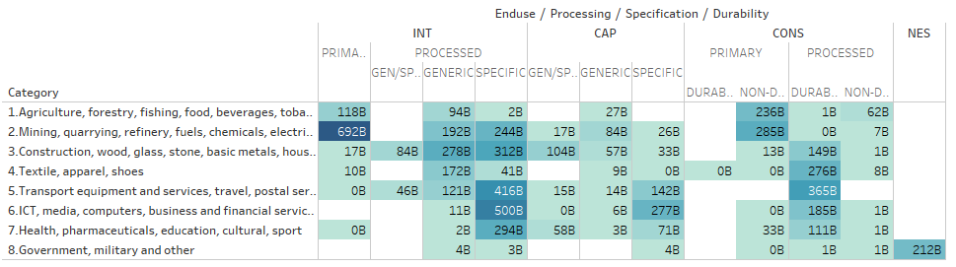

**Way forward**

1. We plan to conduct consultation in period November – December 2018 to gather feedback. When the resulting correlations are reviewed and verified; then we will publish it to UNSD website.
2. We expect the work to be completed by the end of 2018.

1. <https://unstats.un.org/unsd/trade/classifications/correspondence-tables.asp>
2. <https://unstats.un.org/unsd/trade/HS2007-BEC%20-%20Explanatory%20Note.pdf>
3. See E/CN.3/408 (1970).
4. <https://public.tableau.com/profile/uncomtrade#!/vizhome/GVC-ApparelElectronicsFootwareVehicles/Dashboard1>
5. <https://unstats.un.org/unsd/trade/classifications/correspondence-tables.asp>
6. <https://unstats.un.org/unsd/tradekb/Knowledgebase/50090/Intermediate-Goods-in-Trade-Statistics>